Insert school logo here

STUDENT SUPPORT FILE

Name of Student

Date of Birth

School

Date File Opened

Date File Closed

A Continuum of Support

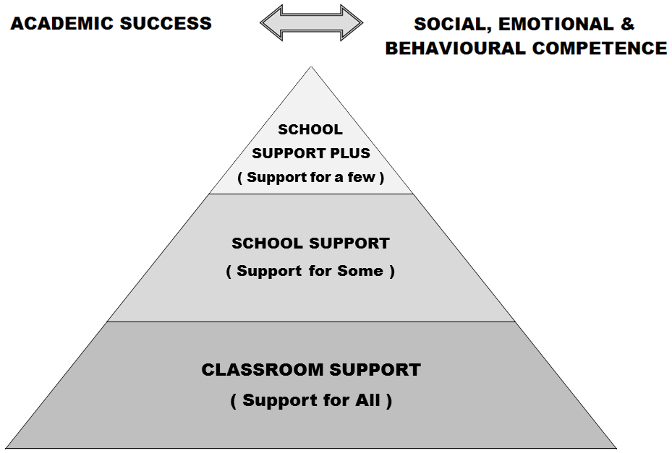

Developing a student support plan is the outcome of a problem solving process, involving school staff, parent(s)/ guardian(s) and the student. We start by identifying concerns, we gather information, we put together a plan and we review it.
Student Support File, Log of Actions

Date Actions

Support Checklist
Name: | Age: | Class:
General Information | Date Checked | Comments
- Parents/ Guardians Consulted
- Information from previous school/preschool gathered
- Hearing
- Vision
- Medical Needs
- Basic Needs Checklist completed
- Assessment of learning- screening

- Observation of learning style/approach to learning
- Observation of behaviour
- Interview with pupil
- Classroom work differentiated?
- Learning environment adapted?
- Yard/school environments adapted?
- Informal or formal consultation/advice with outside professionals?
- Advice given by learning support/resource teacher or other school staff?
- Other interventions put in place in school?
Action needed
Helpful references: SEN: A Continuum of Support: Resource Pack for Teachers, pp. 13-16, 18 to 20; BESD: A Continuum of Support, p 7; A Continuum of Support for Post-Primary Schools, Resource Pack for Teachers, pp32-36; Student Support Teams in Post-Primary Schools, pp20

SUPPORT PLAN* Classroom Support
School Support (Support for Some)
School Support Plus (Support for A Few)
To be completed by the teacher(s).
For help, see SEN: A Continuum of Support - Guidelines for Teachers: BESD: A Continuum of Support – Guidelines for Teachers pp.71-74; A Continuum of Support for Post-Primary Schools, Resource Pack for Teachers, pp. 51, 53, 54, 57.
Student’s name |  |  | Age
Lead teacher |  |  | Class/year
Start date of plan
Review date of plan
Student’s strengths and interests

Priority concerns

Possible reasons for concerns

Targets for the student

Strategies to help the student achieve the targets

Staff involved and resources needed

Signature of parent(s)/ guardian(s)
Signature of teacher
*A consultation with a NEPS psychologist/ other professionals may contribute to this plan.
SUPPORT REVIEW RECORD* Classroom Support
School Support (Support for Some)
School Support Plus (Support for A Few)
To be completed by the teacher(s) as a review of the plan and as a guide for future actions.
For help, see SEN: A Continuum of Support - Guidelines for Teachers; BESD: A Continuum of Support – Guidelines for Teachers; A Continuum of Support for Post-Primary Schools, Resource pack for Teachers; Student Support Teams in Post-Primary Schools.
Student’s name |  | Class/ Year
Names of those present at review |  | Date of Review
What areas of the plan have been most successful and why?

Since the start of the plan, has anything changed in relation to the original concerns? If so, what are these changes, and what have we learned from them?

Have the student’s needs changed since the start of the plan, and if so how?

Recommended future actions – what, how, who, when?

Any comments from the student?

Any comments from the parent(s)/guardian(s comment?

Signature of parent(s)/ guardian(s)
Signature of teacher(s)

Outcome of review (tick as appropriate)
 | Revert to previous level of support- Support for All/ Classroom Support OR Support for Some/ School Support |  | Progress to next level of support- Support for Some/ School Support OR Support for a Few/ School Support Plus
 | Continue at Current Level of Support |  | Request consultation with other professionals
*A consultation with a NEPS psychologist/ other professionals may contribute to this review.

